Information for Chinese students
亲爱的中国学生,
请允许我们用我们的通用校园语言(英语)介绍我们的大学相关信息.
Maastricht University: Leading in learning
Maastricht University is located in the Netherlands and has a strong European and international orientation. Our core values are:

- cherishing and stimulating talented people
- creating opportunities for innovative education
- research relevant to society’s needs

The university has acquired a global reputation with its unique Problem-Based Learning (PBL). We educate students to be independent, enterprising problem-solvers. Problem-Based Learning guarantees a personalized learning environment and intensive contacts with teaching and research staff at all levels.

The university was founded in the year 1976 and consists of 6 faculties:

- Economics and Business Administration (Triple Crown: AACSB, EQUIS and AMBA accredited)
- Law
- Health, Medicine and Life Sciences
- Psychology and Neuroscience
- Arts & Social Sciences
- Humanities & Sciences: including Knowledge Engineering, University College Maastricht and Maastricht Graduate School of Governance.

Maastricht University has approximately 12.000 students, of which 43% comes from abroad. In the 2007/2008 academic year there were 82 Chinese students (including 48 exchange students) studying and 20 Chinese staff (including PHD researchers) working at Maastricht University. In June 2007, Maastricht University established the China Country Team, which consists of staff from different faculties and is responsible for dealing with all China-related issues for the university. Since September 2008, the university offers student buddies to help incoming Chinese students find their way at the university and in the city. Furthermore, informal get-togethers with all Chinese students and staff are being organized regularly every year.

At Maastricht University, you will be taught by professionals from all over the world. One third of the academic staff is from outside the Netherlands, and the university’s current President, Dr. Jo Ritzen, was a former Dutch Minister of Education, Culture & Science and Vice President of the World Bank.

The university currently offers 16 bachelor’s and over 40 master’s programmes. There are also around 20 graduate programmes for professionals and a large number of PhD programmes. Most of these are taught entirely in English.

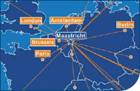

Maastricht is one of Europe’s oldest and safest cities, close to Amsterdam, Brussels, Paris, London and Berlin. The city is well known for the Maastricht Treaty (1992), which marked the establishment of the European Union.
Rankings and accreditations
Maastricht University is one of the 150 universities in the Times Higher World University Ranking. In national official rankings, Maastricht University is always among the top three.
The Faculty of Economics and Business Administration is accredited by AACSB, EQUIS and AMBA, making Maastricht one of the few European universities honoured with this Triple Crown accreditation. The International Business programme is also one of the 2007 Financial Times Top 40 European business schools with a third place for “value for money”. Last but not least, Psychology was rated the top programme in the Netherlands by the German Centre for Higher Education Development (CHE).
In 2005 the German Wirtschaftswoche (Business Week) Magazine published a top 10 ranking of the best European universities according to German human resource managers of large companies. Maastricht University was placed at #8.

Careers and your future
As a graduate of Maastricht University you will be highly sought-after by employers. Statistics indicate that Maastricht University graduates have little difficulty in finding employment at academic level. According to employers, graduates from Maastricht clearly score above average with interpersonal and problem solving skills. Most Dutch employers (64%) were also familiar with the University’s unique Problem-Based Learning, and believed that this accounted for differences between Maastricht alumni and other graduates. One characterised our graduates as:
”much more sociable; better team players (real team players instead of 'people in a group'); consensus based; good problem solving skills”.

Maastricht University actively assists students in preparing for their careers by providing advice and career counselling. Maastricht University Career Services is a central platform for faculties, alumni and study associations that promotes communication with companies and recruitment offices to find job opportunities both in the Netherlands and abroad.

Highly skilled migrant
Since December 2007, foreign students from outside the EU/EEA who have successfully completed a course at universities in the Netherlands now have the opportunity to remain in the Netherlands for a year to look for a permanent position as a highly skilled migrant. Graduates who find permanent employment as a highly skilled migrant within a year will be eligible for a residence permit. The minimum starting salary required for this category of permit has been lowered to € 25,000 / CNY 243,703 (based on exchange rates in September 2008) per year.
MAASTRICHT uNIVERSITY AND China
Partnership development in China
Maastricht University is eager to work together with its Chinese partners and stimulate more talent from China.

Maastricht University has a number of partners in China:
Faculty | Partner
Economics & Business Administration | The Hong Kong University of Science and Technology
 | City University of Hong Kong
 | Chinese University of Hong Kong
 | Guanghua School of Management, Beijing University
 | Shandong University
Law | Central University of Economics & Finance, Beijing
 | Shandong University
Arts & Culture | Chinese University of Hong Kong

Currently Maastricht University follows up on about student exchange with University of Electronic Science and Technology of China and Chongqing University.

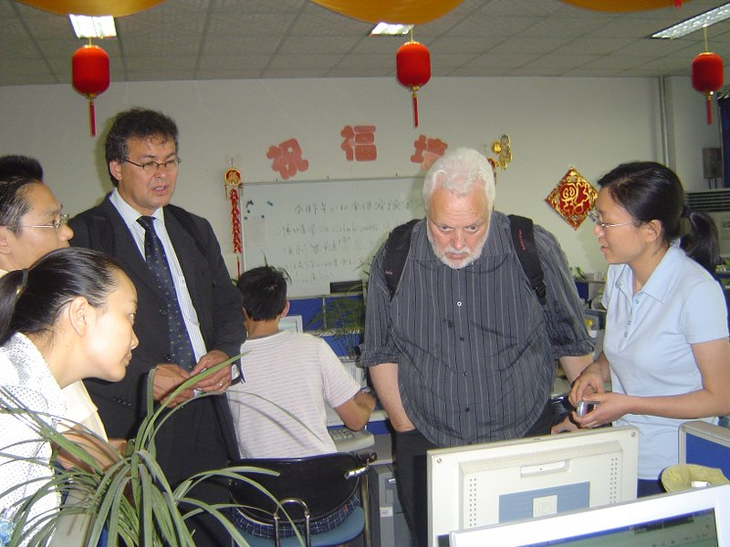

Prof.dr. Louis Boon (Dean of Faculty of Humanities and Sciences and member of China Country Team of Maastricht University, right) and Prof.dr. Tom van Veen (Associate Dean of Faculty of Economics and Business administration, Chair of China Country Team of Maastricht University, left) were visiting University of Electronic Science and Technology of China in Chengdu.

Europe-China School of Law (ECSL)
The Faculty of Law of Maastricht University has joined forces with twelve other European and three Chinese universities to found a Europe-China School of Law (ECSL) in Beijing. Maastricht University is the only Dutch participant in this prestigious international consortium. The consortium aims to offer master’s programmes to students and professionals with the aim of improving the level of knowledge and skills within the Chinese legal profession. The focus of the programme will be on European and international legislation. The project, funded by €17 million worth of European Commission subsidy, will start in October 2008 and last for five years.

Maastricht University staff in China
Maastricht University’s current President, Dr. Jo Ritzen and Prof.dr. Tannelie Blom from the Faculty of Arts and Social Sciences hold the membership from the Chinese Academy of Social Sciences (CASS).
Prof.dr. Anselm Kamperman Sanders from the Faculty of Law is the academic director of the annual IEEM IP Seminar, Intellectual Property Law School and IP Master Classes, Macau SAR, China.
TUition fees
For the years 2009/2010 the tuition fees for non-EU/EEA students have been set as follows:
- Bachelor's students: € 8,000 / CNY 77,985
- Master's students: € 11,500 / CNY 112,103

For the years 2010/2011 and 2011/2012 the tuition fees for non-EU/EEA students have been set as follows:
- Bachelor's students: € 8,500 / CNY 82,859
- Master's students: € 12,000 / CNY 116,977

Please consult www.unimaas.nl for other fees and the latest information.
A rough estimate of study and living expenses
The cost of study materials varies depending on your programme. You may need to pay for essential text books, photocopying costs and other educational materials. Depending on your programme, these run between € 100 / CNY 975 and € 600/ CNY 5,849 per year.

Maastricht is a relatively small city with just under 120,000 inhabitants , so most students walk or cycle. Dutch universities do not have campuses where students are accommodated. Instead, students rent a room on the private market. The rent averages roughly € 250 / CNY 2,437 – € 350 / CNY 3,412 per month. Maastricht University can assist in finding temporary housing facilities if so desired.

Your personal expenses will depend on your lifestyle. We have estimated that you should prepare for an average of €560 / CNY 5,482 a month for total living expenses (excluding the tuition fees).
Type of living expense | Estimated costs per month
Rent: including gas, water, electricity | € 300 / CNY 2,934
Groceries | € 180 / CNY 1,761
Books and materials | € 40 /CNY 391
Insurance | € 40 / CNY 391
Total | Approximately € 560 / CNY 5,477 per month
Financial support
At Maastricht University we believe that financial circumstances should not prevent talented students from studying with us. Therefore Maastricht University offers several scholarships. For an overview see also www.ssc.unimaas.nl/scholarships.

Maastricht University HIGH POTENTIAL Scholarships
The goal of Maastricht University is to strengthen its position as a leading European university. To this end, the university has a proactive recruitment policy for international students, in particular for the master’s programmes. Within this framework, scholarships are made available by the Maastricht University Scholarship Fund to encourage talented students from outside the EEA to follow a master's programme at Maastricht University.

Maastricht University COMPANY scholarships
Maastricht University has several company scholarships available for talented students who want to pursue a master’s programme.

Top 3% of students study 'for free' at Maastricht University
In order to encourage and attract talented people, the top 3% of students study at Maastricht University ’free of charge’. As of the 2007–2008 academic year, the ‘best 3%’ of students are eligible for a scholarship in the amount of their tuition fees for that year. The scholarship will be applied to the following academic year, on the condition that they continue their studies at Maastricht University.

In addition to Maastricht University scholarships, there are other opportunities for financial assistance. A number of scholarships and grants are available at www.grantfinder.nl. Examples include:

Huygens Programme
The Dutch Ministry of Education and Science may grant fellowships to applicants from countries with which the Netherlands has established cultural conventions through the Huygens Programme. Information may be obtained from the Dutch Embassy or representative of the Netherlands in the country or region concerned. www.nuffic.nl

Student grants from the Dutch government
Some students may be eligible for assistance from the Dutch government in the form of a performance grant, a loan and an OV-student card for free use of public transport in the Netherlands. To find out if you are eligible go to www.ib-groep.nl > International visitors > Study in The Netherlands > Grant for tuition or course fees.

Student jobs
Students with the Chinese nationality are allowed to work in the Netherlands, but no more than 10 hours per week. Instead of these 10 hours per week, you could also do seasonal work in June, July and August or have a work placement that does not take up more than 50% of the course of study. Your employer must hold a work permit on your behalf.
Residence Permit
Maastricht University will assist you in applying for an Authorisation for Temporary Residence (ATR).
Criteria for obtaining an ATR are:
- Admission to a Dutch university;
- Financial resources of a minimum of € 765 / CNY 7,457 per month;
- Health insurance (will be arranged on arrival). Liability insurance is advisable;
- Accommodation (Maastricht University offers assistance in finding temporary housing facilities).

Chinese students need a certificate from NESO to obtain a visa to the Netherlands. Please contact NESO China for more information at: helpdesk@nesochina.org.
NESO China (Netherlands Education Support Office China)
Assessment Section
Beijing New World Center
South Office Tower, Rm. 615
3 Chongwenmenwai Dajie
Beijing 100062, China Tel: 010 67089311/12-218 010 67089311/12-219
Fax: 010 6708 2855
Website: www.nesochina.com
Contact

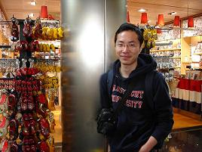
王振 (Wang Zhen )
Bachelor student, Faculty of Economics and Business Administration
Student assistant, International Student Recruitment Office at Maastricht University

Currently I am a second year Econometrics bachelor student at the Faculty of Economics and Bussiness Administration at Maastricht University.
After I finished my Bachelor study of Electronic Information Engineering, I decided to continue my study abroad. I am very glad that I have chosen Maastricht University, because it is the most international university in the Netherlands, where I have the opportunity to meet students from all over the world, and get to know people with totally different backgrounds. Meanwhile, Maastricht University is located in the heart of Europe (within only 15 minutes driving you can go to either Belgium or Germany) which provides me the chance to explore and experience different cultures.

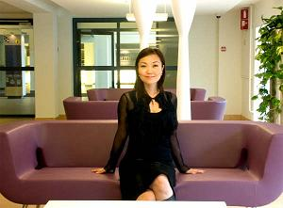
张晓燕 (Zhang Xiaoyan)
MSc, Alumnus Faculty of Economics and Business Administration
Regional account manager China at Maastricht University

Currently I am working for Maastricht University as regional account manager China. In September 2004, I started my International Business master study at Maastricht University, my major was Organization. The study experience at Maastricht University has helped me to become a good team player and problem solver. Furthermore, my interpersonal skills have been also improved during my study. To be honest, I was reborn in Maastricht.

If you want to know more about life in Maastricht or wish more information about the university and its study programmes, do not hesitate to contact us (in Chinese if you prefer) at: info-china@ssc.unimaas.nl.

马斯特里赫特见!

USEFUL ADDRESSES IN ChinA

Netherlands Education Support Office, China
New World Center, South Office Building, Room 615
3 Chongwenmenwai Street,
Beijing 100062
P.R. China
Tel: 010-6708.9311/12 ext 205
Fax: 010-6708.4087
E-mail: info@nesochina.org
www.nesochina.org
Embassy of The Netherlands
Liangmahe Nanlu 4
Beijing 100600
P.R. China
Tel: 010 8532 0200
Fax: 010 8532 0300
E-mail: PEK@minbuza.nl
www.hollandinchina.org

English Language tests
For detailed information on the English Language Tests please see the following websites:

IELTS: www.ielts.org
TOEFL: www.toefl.org

Although this text was made with the utmost care, no rights can be derived from it.

Source: “Survey among employers of alumni from the Faculty of Economics and Business Administration of Maastricht University, Research Centre for Education and the Labour Market, Faculty of Economics and Business Administration, Maastricht University, January 2006.

